Connecting an LRS to OpenLabyrinth

An LRS is a Learning Record Store, a special database designed to handle xAPI statements. For more information about what an LRS is, there is lots of good info out there: e.g. https://tincanapi.com/learning-record-store/

The hardest part about this may be choosing which LRS to use. There are many out there and the list is growing all the time. Both ADL and Rustici maintain lists of current LRS vendors.

We have tested OpenLabyrinth with the following LRS database engines:
- GrassBlade LRS – cheap and simple to maintain
- SCORM Cloud – very standards-compliant
- Wax LRS – stricter statement handling; more analytics
- Watershed LRS – seriously powerful with great analytics
- Learning Locker – open-source, based on MongoDB
- SCORM Engine – simplest way to bridge xAPI to SCORM

We have not yet seen a comparative table of LRS offerings but, given that things are changing so quickly at present, such a table would be obsolete even before posted.
Some LRSs can be installed onto your own server hardware but many are designed to be hosted on cloud services, as the data quantities can quickly become very large.

Once you have an account on an LRS, you will generally be given some information on the connection parameters that you need. Make a note of the LRS endpoint, username and password required. Note that it can be a wee bit confusing because you will have your own username and password that you use to connect to that web site as an LRS administrator. But the LRS endpoint will have a machine-oriented username and password that OpenLabyrinth will need when connecting to the LRS.

You must have superuser privileges in OpenLabyrinth to do this next bit. In OpenLabyrinth, choose menu Tools | LRS… - this will show you the LRS Manager page. Click on the blue [Add LRS] button.

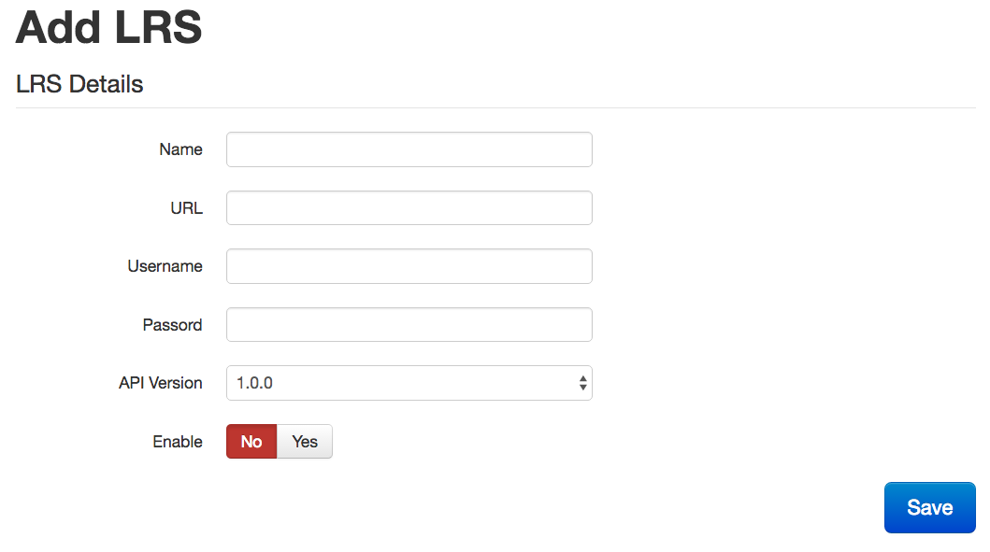

The LRS Name can be whatever you want that you find meaningful.
The URL is that of the LRS Endpoint, not just that of the LRS web site.
The Username is often referred to as the Key by the LRS.
The Password is often referred to as the Secret by the LRS.

Note that the Key/Secret pair is generated by the LRS when you create your account on the LRS and is specific to that account. They are usually long, unreadable strings. Copy/Paste them from one site to the other during set up. Do not reuse Key/Secret pairs.

Remember to Enable the LRS in your OpenLabyrinth settings when you want to send data to that LRS. You can toggle this on/off in your settings without changing the rest of your connection details, if you want to intermittently enable that particular LRS during the testing phase.

Note that you can have multiple groups of LRS connections set up at once. You can even enable multiple Learner Record Stores at the same time. However, we do not recommend this as this places quite a load on the OpenLabyrinth server. If you do need to store your xAPI statements on more than one LRS, it is helpful to remember that the LRS itself is capable to connecting to another LRS directly and that you can federate your statements across multiple stores, without having to bog down the OpenLabyrinth server.

There are a number of interesting learning designs and situations in which you might want to do this. If you are interested in exploring this further, please , feel free to contact us.

