Setting up Realtime xAPI Reports in OLab

You must be a superuser on OpenLabyrinth for any of the following to work.

Using real-time xAPI reports can sometimes be very helpful but there are limitations to this. Be aware that sending many xAPI statements from a complex case, being played by many concurrent users, will really slow down the response from the OLab server. Be responsible in how you use this or you may lose your superuser privileges.

The advantage of using real-time xAPI reports is that you can start to use this mechanism to generate interactivity between different platforms, allowing for cross-platform simulation activities that are linked in creative new learning designs.

You do need to modify your case to make use of real-time xAPI reporting so you cannot do this on any case where you do not have author privileges. If in doubt, make a Duplicate of your case before seriously modifying it.

When creating real-time xAPI reports, OLab will only transmit the following xAPI statements for the following:
- when a case is Initialized or started
- when a Must Visit or Must Avoid node is touched
- when the value of the Main Counter for the case is altered
- when the case is Completed

Note that you have to edit the Nodes to set the Must Visit or Must Avoid flag. Note that there can only be one Main Counter for a case. See the User Guide for more details on how to set these parameters for a case.

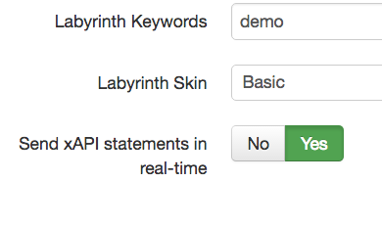
Finally, in the Details page for that case, set the switch [Send xAPI statements in real-time] to ‘Yes’.

Now, every time that case is played, xAPI statements will be immediately sent to an Enabled RLS.

