Setting up Post Hoc xAPI Reports in OpenLabyrinth

You must be a superuser on OpenLabyrinth for any of the following to work.

Using post hoc reports is the commonest approach and will work for most situations. The advantages of this approach is that you can extract a wide range of data from your user sessions without too much work. You can also pull data from old sessions that were played long before we had any xAPI capability on our systems at all. In fact, even before xAPI existed if you really want – is this time travel or what?

Firstly, you do not need to modify the actual cases themselves. Next, make sure that you have an LRS properly connected and that you have access to this LRS data. No point in processing it if you can’t use it. Also please be considerate to other users of these servers – processing a large data set can slow down OpenLabyrinth for other users.

Once you have your LRS connected to OpenLabyrinth, run a small test set of data to make sure that you are getting the statements that you expect. You might want to use a small real-time case for this. See here for more info on how to do this.

xAPI Reporting for a set time segment

The simplest way to generate a swathe of xAPI statements is to simply request an xAPI report for a set time interval, with a start and end date. This is not at all selective and will currently report on all sessions in that time slot. This will be refined further in due course. Keep your time slot quite short or you will find that you will hit processing limits and will get no statements at all.

To do this, select menu Tools | LRS…

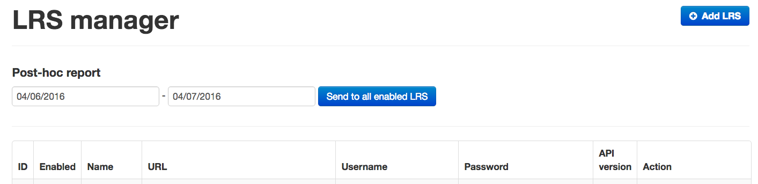

In the date range, select a start and end date then click on [Send to all enabled LRS].

Note that this will take several minutes to process. It will also send xAPI statements to any LRS that is currently active on OpenLabyrinth. See the ‘Enabled’ column in the table of LRSs on this same page. If unsure, please check with your admin. Sending heaps of unwanted statements to the wrong place is a sure way to lose your superuser privileges.

Now go to your LRS and examine your generated statements.

xAPI Reporting for a Scenario

A Scenario in OpenLabyrinth is a way of grouping together a set of users, cases and other activities into a single item. We use Scenarios lots in OpenLabyrinth for exams, studies, classes where you want learners to do activities in a certain order. Consult the OpenLabyrinth User Guide for more information on how to set up a Scenario.

Once you have a Scenario, and a number of Users have played the cases in the Scenario, you can then generate an xAPI statement set as part of a report for that Scenario. In principle, this is similar to generating a 4R report, or an SCT report. See the User Guide for more info on these.

Go to the Scenario Manager with the menu Scenarios | Manage Scenarios… then pick your Scenario from the drop-down list.

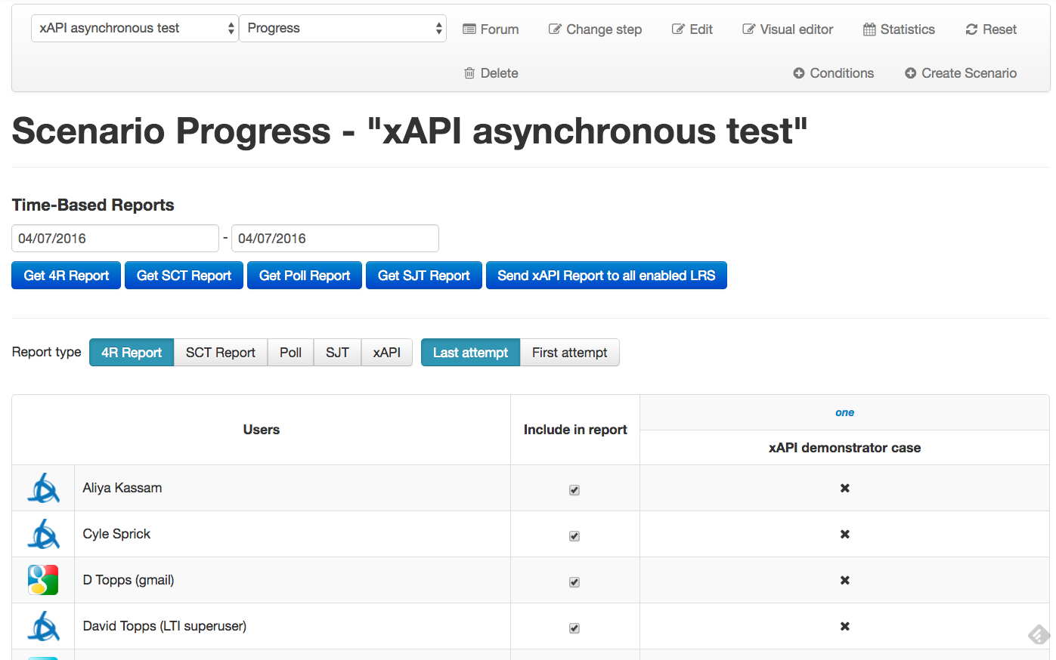

Select a date range and then click on the [xAPI] button to choose that Report Type. Finally, click on the dark blue [Send xAPI Report…] button. This can take many minutes to process, especially if you have a large number of users.

Now go to your LRS and examine your generated statements.

